Deploy a static site via GitHub → VM → Nginx

Objective: Create a public web endpoint that serves a provided index.html using Nginx on a cloud VM, with the file sourced from a GitHub repository.

Goals:
1. GitHub repo
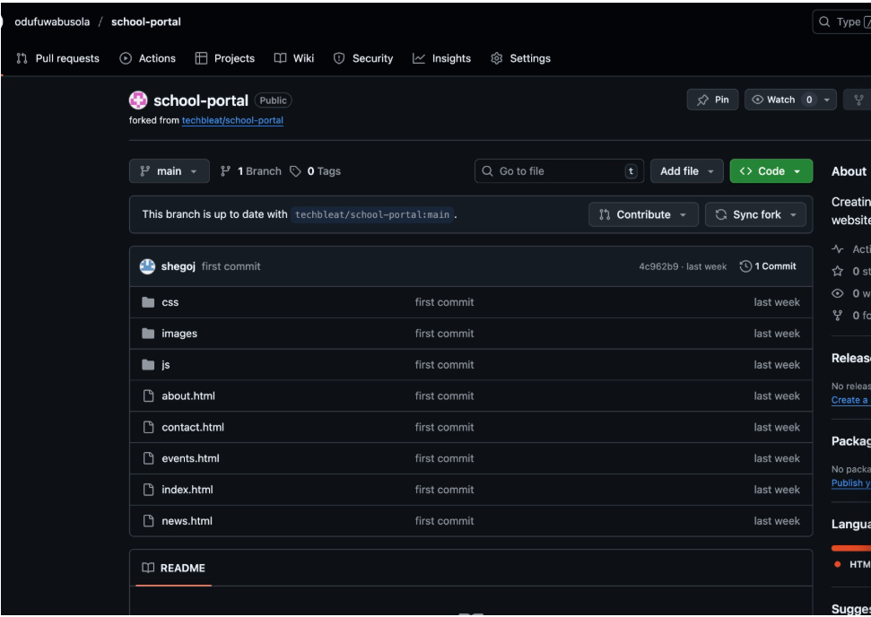

- Create a new GitHub repository (public)—Please share
https://github.com/odufuwabusola/School_portal.git

- Add index.html at the repo root and push it.
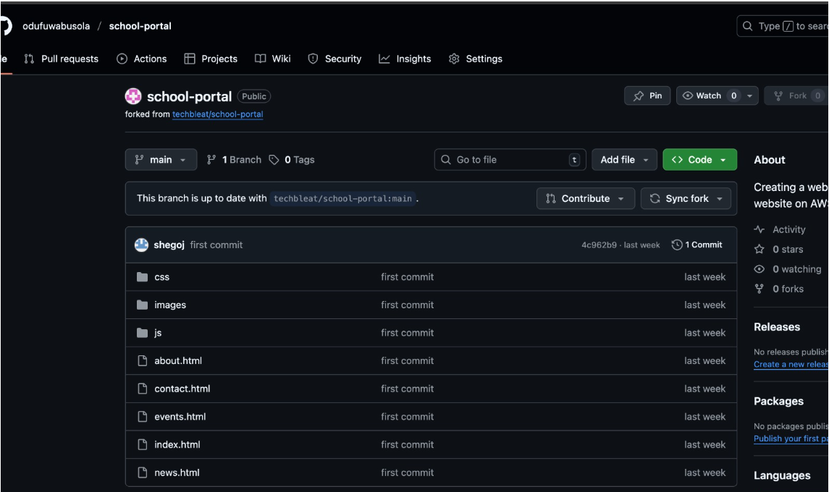

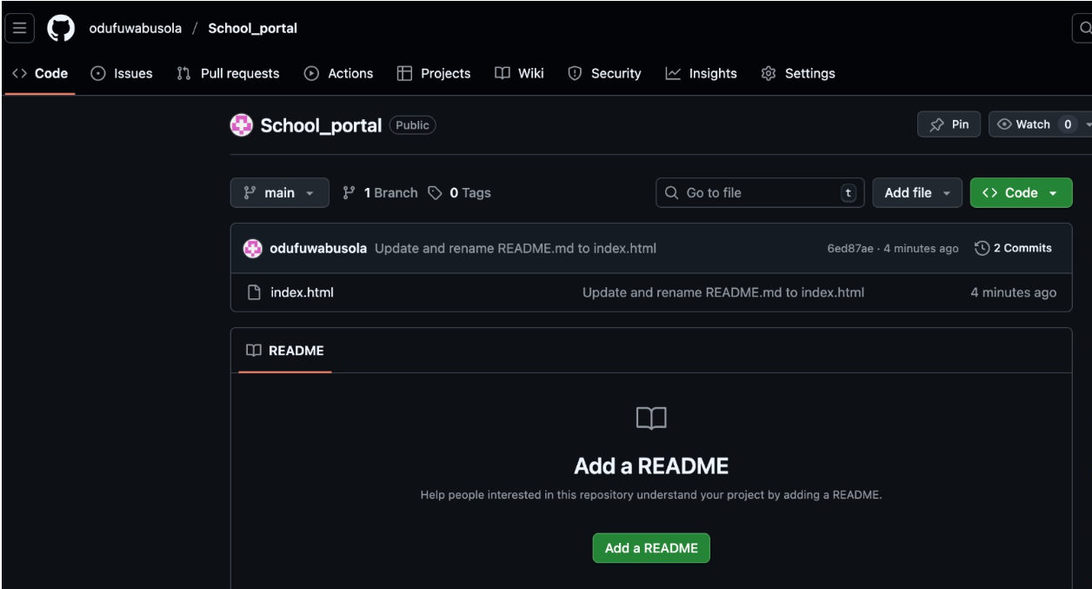

2. Cloud VM (choose one: AWS or Azure)
- Provision a small Linux VM (e.g., Amazon-Linux/Ubuntu 22.04) with inbound HTTP (80) open.
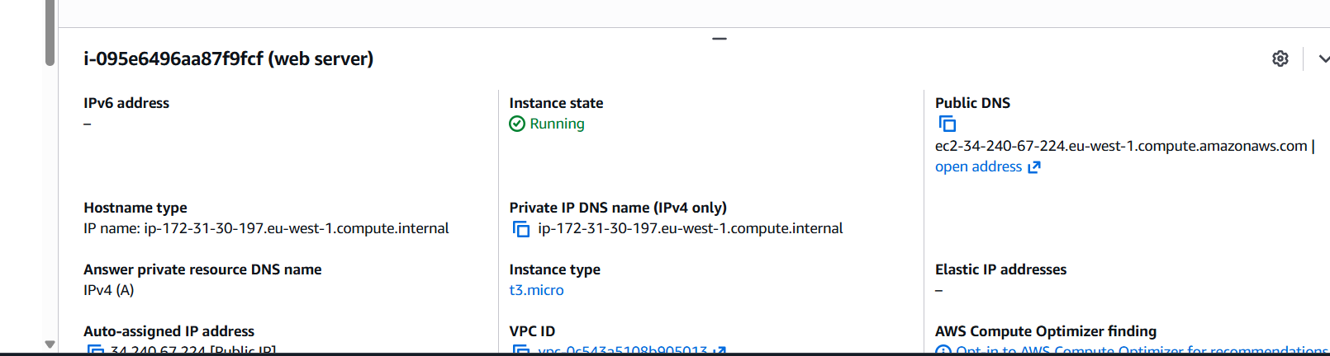

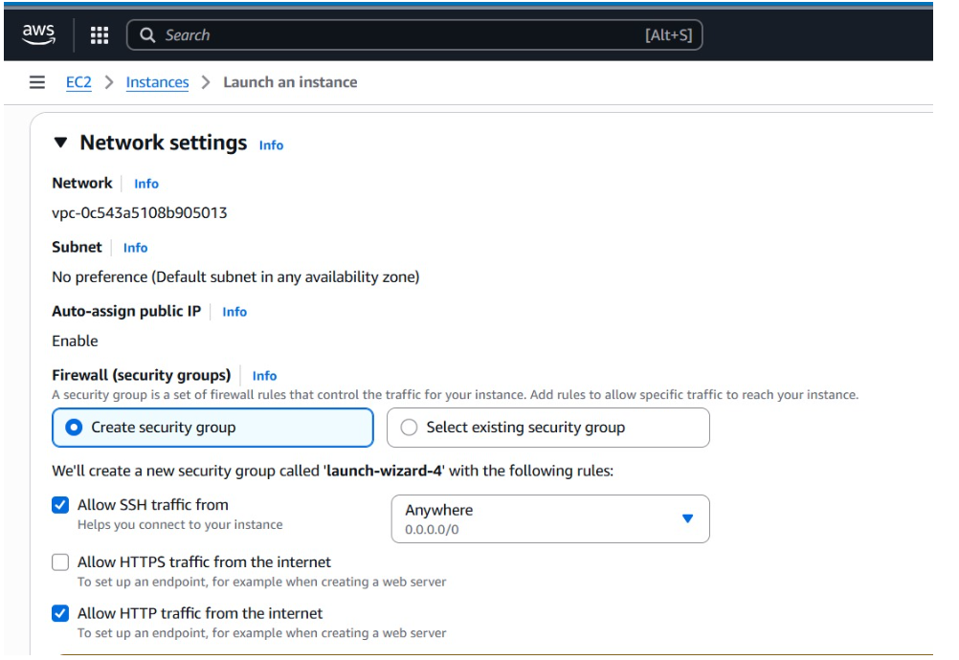

- Provide the VM’s public IP or DNS. ec2-34-240-67-224.eu-west-1.compute.amazonaws.com
ec2-52-215-222-140.eu-west-1.compute.amazonaws.com

3. Retrieve site via Git
- SSH into the VM, install Git, and clone the repository to the VM.
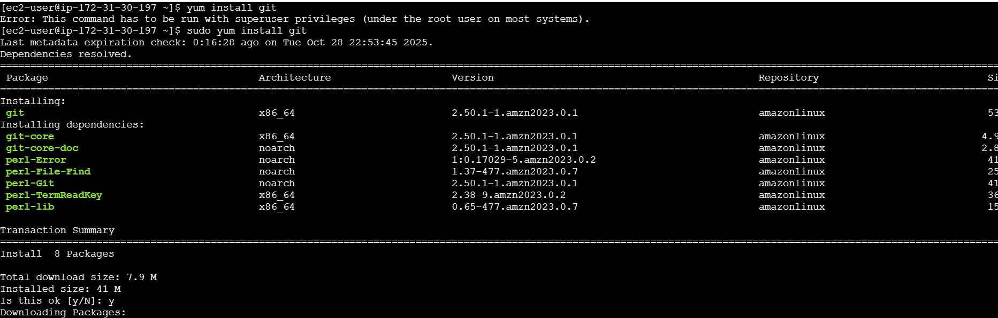

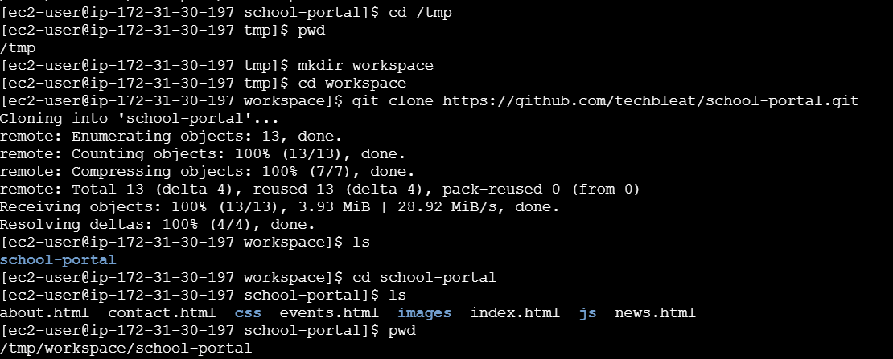

4. Install & configure Nginx
- Install Nginx.
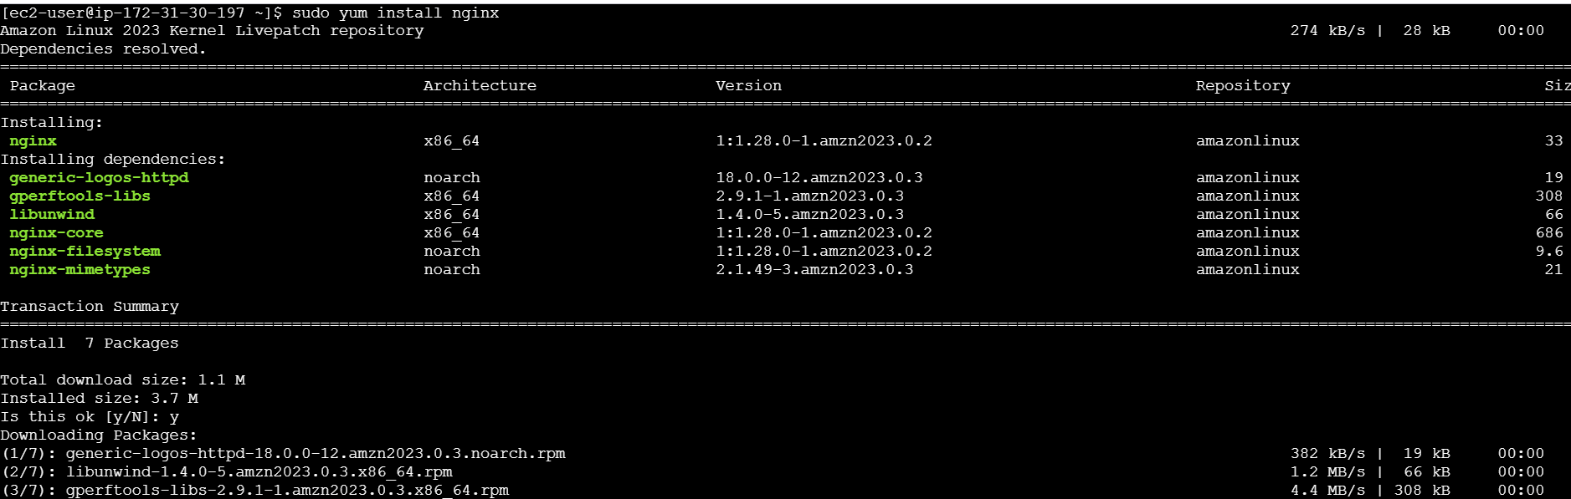

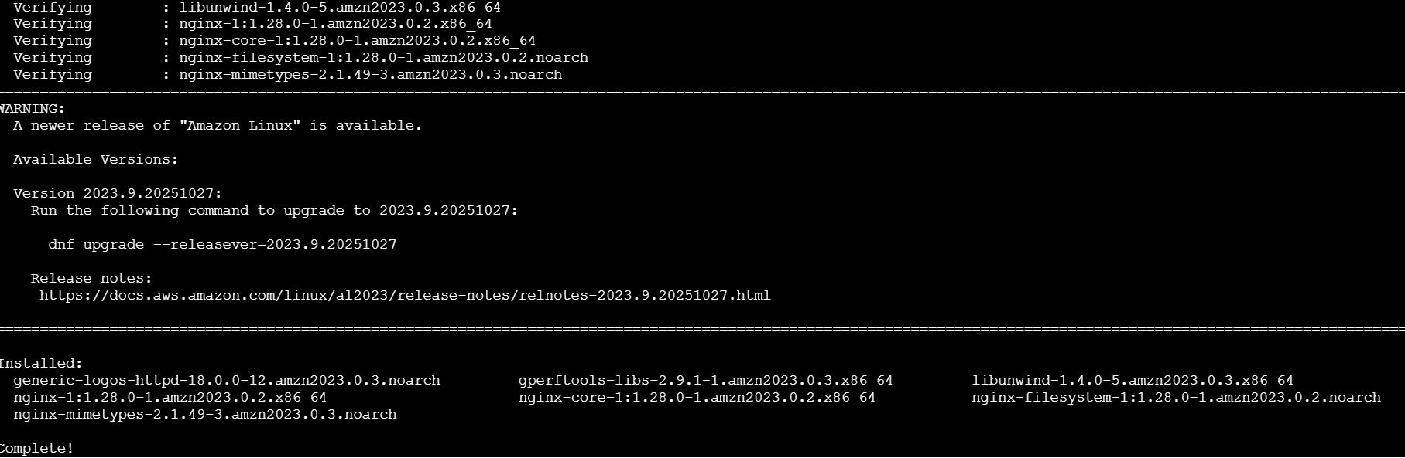

- Place index.html in Nginx’s web root

- Start/enable Nginx and verify it serves index.html.
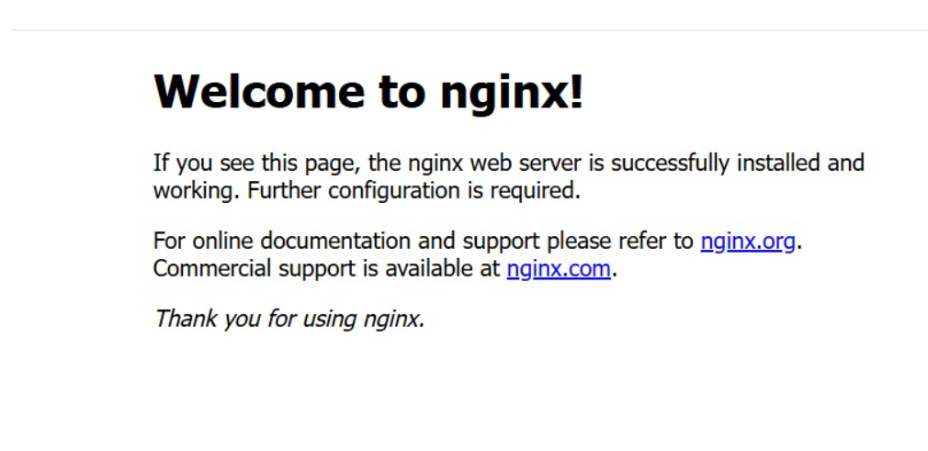

5. Verification
- Access the VM’s public IP/DNS over HTTP and confirm the page loads.
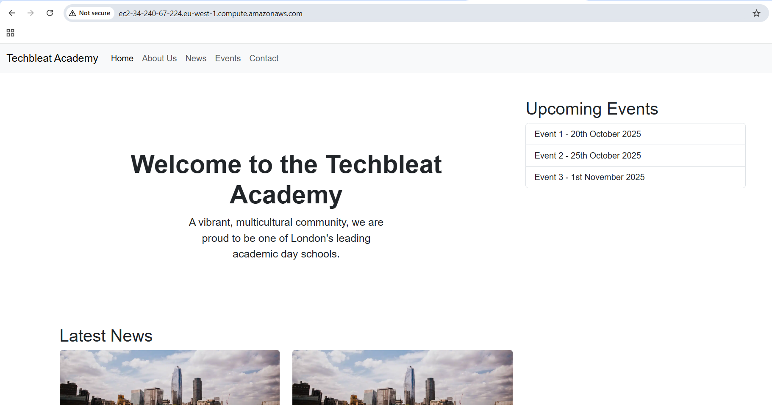

- URL: http://ec2-34-240-67-224.eu-west-1.compute.amazonaws.com

- Share the final URL and the commands you used.

